Short Bio

Juan is a devoted Christian whose faith is the cornerstone of his life. He embodies values like kindness, compassion, and integrity, which shine through everyday interactions. Known for his warm smile and gentle spirit, he consistently goes out of his way to uplift those around him. Whether lending a listening ear to a friend in need or volunteering at his local church, Juan is always the first to offer help, exemplifying the true essence of selflessness.

Family holds a special place in Juan's heart. He cherishes every moment spent with his loved ones, prioritizing the creation of lasting memories together. His home is a vibrant hub of laughter and love, where he nurtures deep connections and fosters an environment of support. Juan believes that personal growth is a lifelong journey, dedicating time to exploring his hobbies, such as playing guitar and hiking, which enrich his life and balance his responsibilities.

Juan is passionate about collecting consoles, Pokémon cards, and Sonic merchandise, which truly reflects his love for gaming and nostalgia. His collection shows a variety of classic and modern consoles. The Pokémon cards, ranging from rare holographic to beloved favorites, bring back memories of childhood battles and trading with friends. Additionally, his Sonic merch adds a fun twist, featuring everything from action figures to vintage posters.

Juan has made great strides in his photography journey, becoming a well-known photographer in his community. His talent for capturing candid moments and stunning landscapes has earned him a loyal following, with many seeking his expertise in events and portraits. Recently, he also celebrated a significant personal milestone by being baptized, marking a new chapter in his life. This blend of creative success and spiritual growth showcases his dedication to his craft and values, making him an inspiring figure to those around him.

Beyond his many admirable qualities, Juan is genuinely beautiful inside and out. His caring nature and willingness to help others radiate positivity and inspire those around him. He is a shining example of how faith, love, and compassion can transform lives, making him a cherished friend and a beacon of hope in his community. Juan truly exemplifies what it means to live a life dedicated to service and love. His unwavering commitment to his beliefs and the well-being of others inspires all who know him, showcasing the profound impact one individual can have on the lives of many.

10 Interview Questions

1. What's your favorite way to spend a weekend?
   1. My favorite way to spend a weekend is by spending time online with my online friends or my real-life friends, depending on who wants to hang out first.
2. Do you have any hobbies that you're super passionate about?
   1. I am super into a few things, the first being Christianity; I am always looking to be closer to Jesus, and I always want to learn and gain that wisdom. My second passion splits into a few categories: anything related to collecting old consoles, Pokémon cards, or sonic-related merch. I also love photography.
3. What would it be if you could pick one activity to do every day for the rest of your life?
   1. If I could pick one activity to do every day for the rest of my life, it would be preaching the Gospel to others who need to hear it. This would partially fulfill my dream of becoming a missionary.
4. Are you more of an introvert or an extrovert when it comes to socializing?
   1. I cannot accurately answer this question; it depends on who I am talking to and the subject. I do not like to speak and insert my “knowledge” on topics I do not understand or know about as much as others.
5. What skill have you always wanted to learn but haven't had the chance to yet?
   1. I always wanted to learn how to play the guitar or drums. From how often I listen to music, it would make sense to learn how to play it.
6. How do you usually unwind after a long day?
   1. After a long day, I like to sit down, relax, watch YouTube videos, or play video games.
7. How often do you spend time with other people in the community?
   1. I attend a church down the street at least once a week, so engaging with the community and my neighbors is easier.
8. What's the most adventurous thing you've ever done?
   1. The most adventurous thing I have done is travel to a few other states for my photography goals that I set. For example, take a picture of a tree that only exists in a specific state, like the Pacific madrone in Washington.
9. How would others describe you?
   1. I think others would describe me as funny, respectful, kind, honest, optimistic, considerate, reliable, open-minded, and friendly.

10. What's something that always puts you in a good mood?

a. Music will always put me in a good mood; no matter my mood, I can pick out songs that will make me feel way better.

Portrait

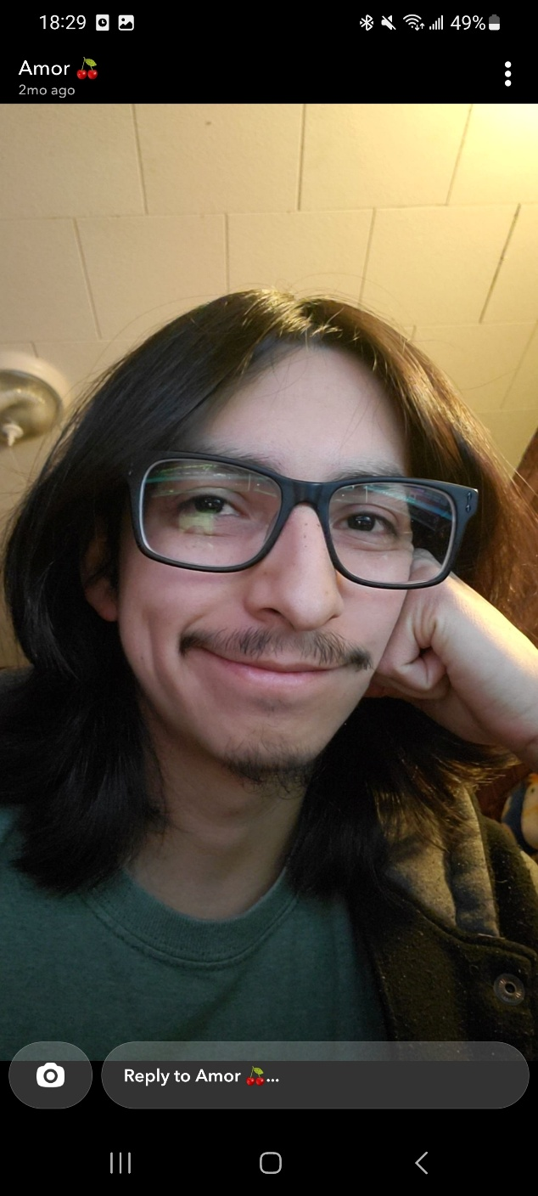

Hobby Photos

Accomplishment photos

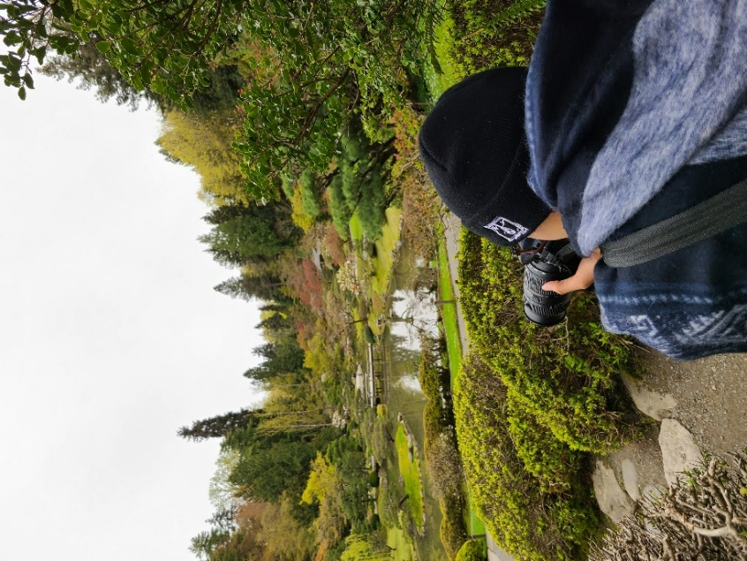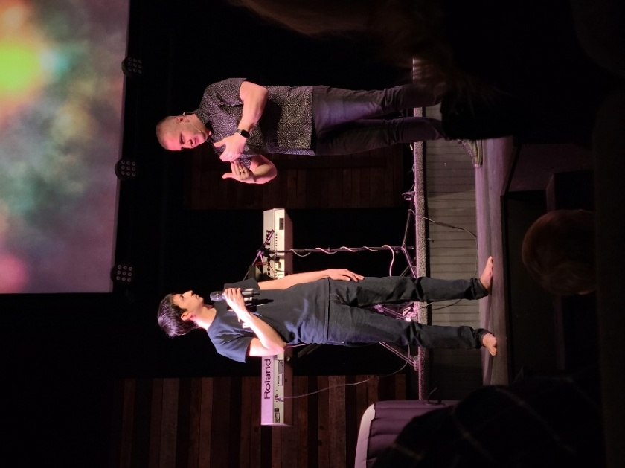

Website Prototype/Colors/Sketch

